Participant Information and Consent Form

Implementing a tailored model of palliative care for people with intellectual disability

This sheet has information about a research project.

The project is about palliative care for people with intellectual disability.

 | Palliative care is help for people who have an illness or a condition that they will die from.
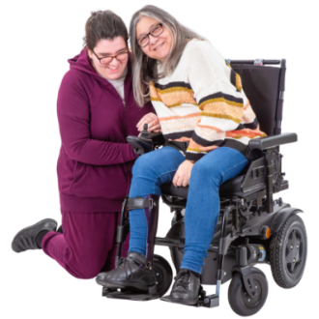 | You can ask someone you trust to help you understand this sheet.

Who is doing the research?

My name is Julian Trollor. I am a researcher at the University of New South Wales. I am working with

Rachael Cvejic

and

Janelle Weise

and

Olivia Burton

and
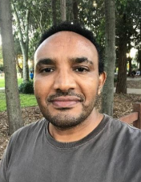

Amanuel Hagos
What is it about?
This research is about testing new palliative care information resources for people with intellectual disability.

We want to hear what people with intellectual disability think about the resources.

Who can take part in the study?

People who:
- self-identify as having intellectual disability
- are aged 18 years old and over
- Currently use palliative care services at one of the pilot sites (South Western or South Eastern Sydney Local Health District)
What does taking part involve?

We will ask you to call us and answer some questions to check if you can take part in the study.

If you cannot take part, we will not keep any information about you.
 | If you can participate, we will ask you to come to two interviews.
 | An interview involves being asked questions by someone.
In the first interview we will ask you about
- you and your health
- what you think about palliative care
- the resource topics
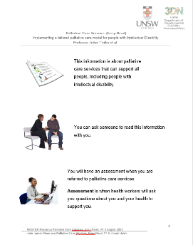 | In the first interview we will also give you the resources to keep.

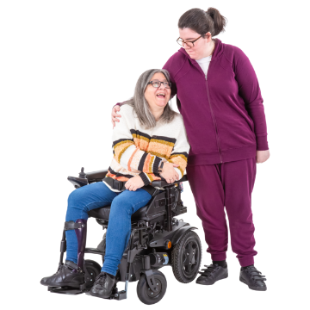
If you want you can bring a support person with you.

The second interview will be one month later.

In the second interview we will ask you
- what you think about the resources

You can do the interviews

- in person or

- using phone or video (e.g. Zoom or Skype).

You can choose which questions to answer.

You can say no if you do not want to answer a question.
We will ask to record what you say in the meeting/interviews.

If you do an interview and do not want us to record, that is OK. We will take notes instead.

If you use communication aids we will ask if we can take a photo of them.

We will use the photos to help us write down what you said.

Each interview will take about 90 minutes.

You can also do the interviews over shorter sessions if you would prefer.

In person interviews can be held at
- A private room at UNSW in Randwick
- Your home
- A room in one of the hospitals in South Western Sydney or South Eastern Sydney local health district

You will get $100 in gift vouchers for each interview.

Do I have to take part?
You only take part if you want to.

You can say no. It is your choice. No one will be angry if you say no.

Even if you say yes, you can change your mind later and stop taking part.

If you do not want to take part in this study anymore you can fill out the form at the end of this sheet.
What will happen to my information?

We will store your information at 3DN, UNSW Sydney on our computers.
The computers have a password.

Only the researchers will know the password.

We will keep the recordings of your interview in these computers as well.

We will keep your information for 5 years after we write reports about it.

We will keep your information private.
We will not tell anybody your name or where you live.

No one will know it was you who took part.
We will write about what we find out.
If you want, we will send you a summary.

If you say it is OK, we may share what you said with a group of advisors who are helping with this project.

Who can I talk to about the research?

If you have any questions, you can contact:

Name: Olivia Burton

Phone: 02 9348 1732
Email: IDPalliativeCare@unsw.edu.au

If you want to complain about the research, you can contact the Human Research Ethics Coordinator. It is their job to listen to you and find out what happened.
Phone: 02 8738 8304

Email: SWSLHD-ethics@health.nsw.gov.au

Tell them this number: 2023/STE03494

If you feel upset after taking part, you can talk to some who supports you or call one of these numbers.

Beyond Blue: 1300 224 636

Anyone can call this number any time of the day.

They have a website too. It is www.beyondblue.org.au
What if I am having a crisis?

A crisis is when you are very upset and need help straight away.

If you are in a crisis, you can call one of these numbers:

Suicide Call Back Service: 1300 659 467

They have a website too. It is
www.suicidecallbackservice.org.au

Lifeline: 13 11 14

They have a website too. It is www.lifeline.org.au

Anyone can call these numbers any time of day.

If you have a hearing impairment you can call Lifeline through the National Relay service. Here is how:

For TTY phone 133 677 then ask for
13 11 14

For Speak and Listen phone 1300 555 727 then ask for 13 11 14

Thank you for reading.

This information sheet is for you to keep.

I want to take part

Implementing a tailored model of palliative care for people with intellectual disability

I am signing this form because I understand about the research, and I want to take part

☐ Tick this box if you have read the information about the study.
Or if someone has explained the study to you.

☐ Tick this box if you understand that you can change your mind later and not be in the study anymore.

☐ Tick this box if you want to bring a family member or support person with you.

☐ Tick this box if you agree we can share what you said with a group of advisors who are helping with this study.

☐ Tick this box if you want us to tell you what we find out from the research.

My signature: ________________________________

Date: ________________________________

My phone number: ________________________________

My address: ________________________________

________________________________

My email address: ________________________________

I understand that you will only use my contact details for me to take part in the research and to tell me about the findings afterwards.

Witness signature (a witness is someone who saw you sign the form):

________________________________

Date: ________________________________

I do not want to take part anymore

Implementing a tailored model of palliative care for people with intellectual disability

I am signing this form because I changed my mind. I do not want to take part in the study anymore. I understand that my information cannot be removed from reports that have already been written.

☐Tick this box if it is OK for the researchers to keep information you have given so far.

OR

☐Tick this box if you want the researchers to destroy all information collected about you.

My signature: _____________________

Date: _____________________

Witness signature (a witness is someone who saw you sign the form):

_____________________

Date: _____________________

Send this form to:

Prof Julian Trollor
3DN, UNSW Medicine & Health
Discipline of Psychiatry & Mental Health
Room 241, Level 2, Biolink Building E25, UNSW
Sydney, NSW 2052.

Or email it to IDPalliativeCare@unsw.edu.au

You can also call us on the phone 02 9348 1732

