Improving Preventative Health Care Project – Project Summary
Why we are doing this project
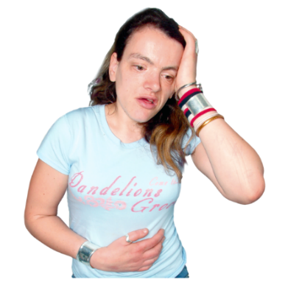 | People with intellectual disability have poor health more than people without intellectual disability.
 | This might not have happened if these people could easily use preventive health care.
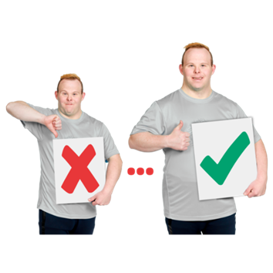 | Preventive health care are things that support people to  - Stay healthy  - Get better quickly when they are sick  It is a type of health care.
Health care is the support you get from health workers to

- Stay healthy

- Get better if you are sick or have hurt yourself badly
 | Health workers are people who work to help you with your health.
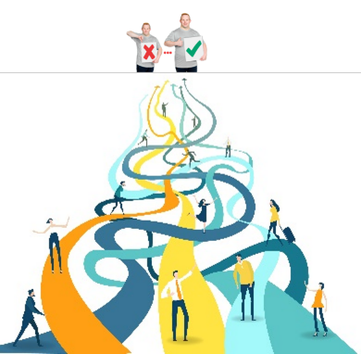 | There are different ways to get preventive health care.
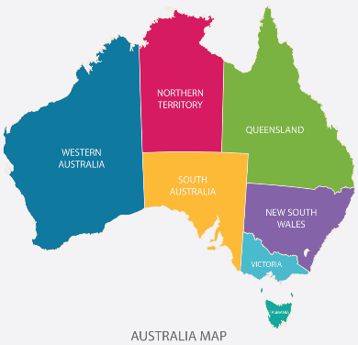 | It can be hard for people with intellectual disability to use preventive health care in Australia.
Aims of this project
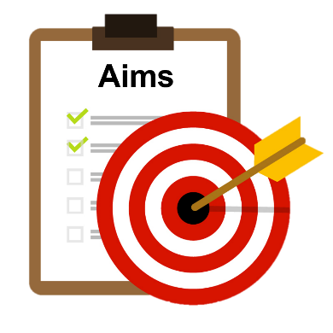 | An aim is where we want to go or what we hope to do.
 | This project wants to make it easy for people with intellectual disability to get preventive health care.
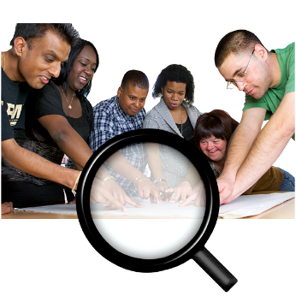 | We want to work with people with intellectual disability to think about a new way to provide preventive health care
What we will do in this project
 | To make it easier for people with intellectual disability to get preventive health care we will follow the steps below.
 | Step 1
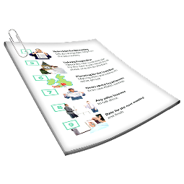 | To find out the gaps in Australias preventive health care we will  - Look at government documents  - Communicate with different groups
 | To communicate is how you understand and share your feelings or information.
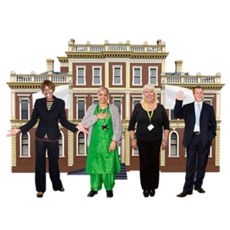 | The government is a group of people who control and help organise things to protect and support people in certain areas.
We will look at government documents called policy.

Policy documents help guide what people and organisations do.
 | Step 2
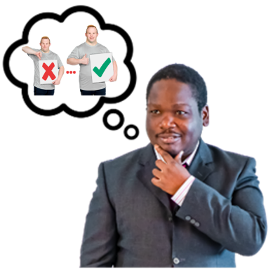 | Build a new preventive health care model for people with intellectual disability.  A model is a way of thinking about and providing care.
 | Step 3
 | Test the model to see if it will help people with intellectual disability to use preventive health care.
How we will tell people about our project
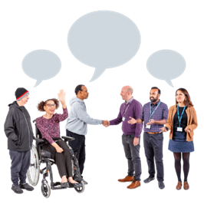 | We will tell people about our project by sharing information
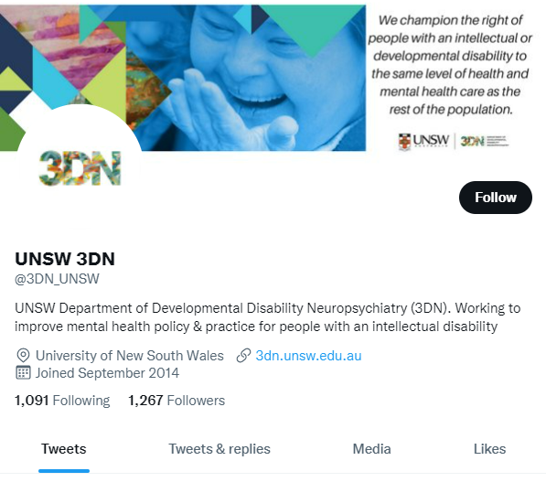 | - On social media like Twitter
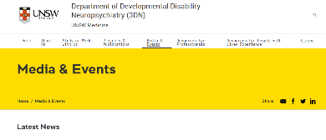 | - With news articles on the 3DN webpage
- In a type of document called a research paper

We will ask organisations to review and share these papers.

This is called a publication.
Learn more
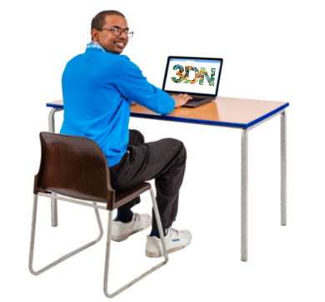 | If you would like to learn more about our project go to our project page www.3dn.unsw.edu.au/nhmrc-preventive-healthcare
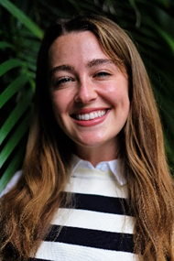 | Or contact Jess.  Jess is a researcher on the project.  You can contact her from 8:00am to 4:00pm Monday to Friday.
To contact Jess

- Call +61 2 9348 0903

- Email jessica.ward1@unsw.edu.au

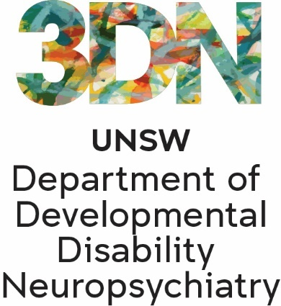 | Who wrote this Easy Read  Tahli Hind, Bela Laginha, Dominique Abagi, Julian Trollor, and Janelle Weise.  Where these people work  Department of Developmental Disability Neuropsychiatry UNSW Sydney.  Also known as 3DN.
The information in this part of a series of easy read resourcs about
- Different types of preventive health care
- Who can provide this care

For information on how to support people to use Easy Read go to www.3dn.unsw.edu.au/professionals_toolkit

© Department of Developmental Disability Neuropsychiatry UNSW Sydney 10.08.23 v3

No changes can be made without asking the people who wrote this sheet.

